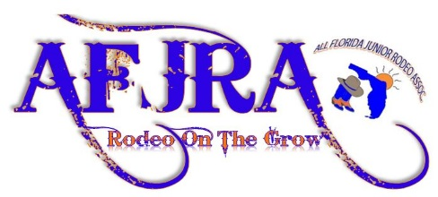
2023 - 2024 RODEO SEASON
PRESIDENT: Whitney Savoie (337)274-2369 ropenwhit@hotmail.com
VICE PRESIDENT: Heather Fleckinger (321)288-6180
STATE SECRETARY: Katie Russo-Valdera (954)332-8614 afjrastsecretary@gmail.com
TREASURER: Brigette Ryon (321)624-1011 afjratreasurer@yahoo.com
RODEO SECRETARY: Nikki Atkinson (386)479-2570 afjrarodeosec@yahoo.com

Sponsor’s Name______________________________________________________________
Address: _____________________________________________________________________ Phone Number: _______________________________________________________________
Please remember any donation made is deeply appreciated by all of the young Cowgirls and Cowboys of the Association.
____PLATINUM SPONSOR $10,000 (PREMIER SPONSORSHIP) – Business logo/emblem on the Year End Championship Saddles and contestant back tags. (Flag and Banner provided as well as, the Platinum Sponsors name will be listed on our Facebook Page, and Web-site)
____GOLD SPONSOR $1500.00-. Saddle / Corporate sponsor (Banner provided as well as, the Sponsor’s name will be listed on our Facebook page, and Web-site)
____SILVER SPONSOR $500.00- Sponsors will be provided a banner with name/logo. (Sponsor’s name will be listed on our Facebook page, and Web-site)
____BRONZE SPONSOR $250- Sponsor’s will be listed on our Facebook page and Web-site.
QUEEN SPONSORSHIP- ____SADDLE $1500 ____Buckle $250 ____ Crown $250
____OTHER- I wish to support AFJRA with my gift of $___________
Please fill out and return to: All Florida Junior Rodeo Association, Inc. (AFJRA)
Attn: Brigette Ryon 3591 N Canoe Creek Rd. Kenansville, FL 34738
Make checks payable to AFJRA. A receipt for your tax deductible contribution will be mailed to you.
Thank You,
Brigette Ryon

